1.Open your Windows or Linux system, use the command line to assign a static IPv6 address to your primary network adapter, and verify the configuration using ipconfig (Windows) or ifconfig/ip (Linux).
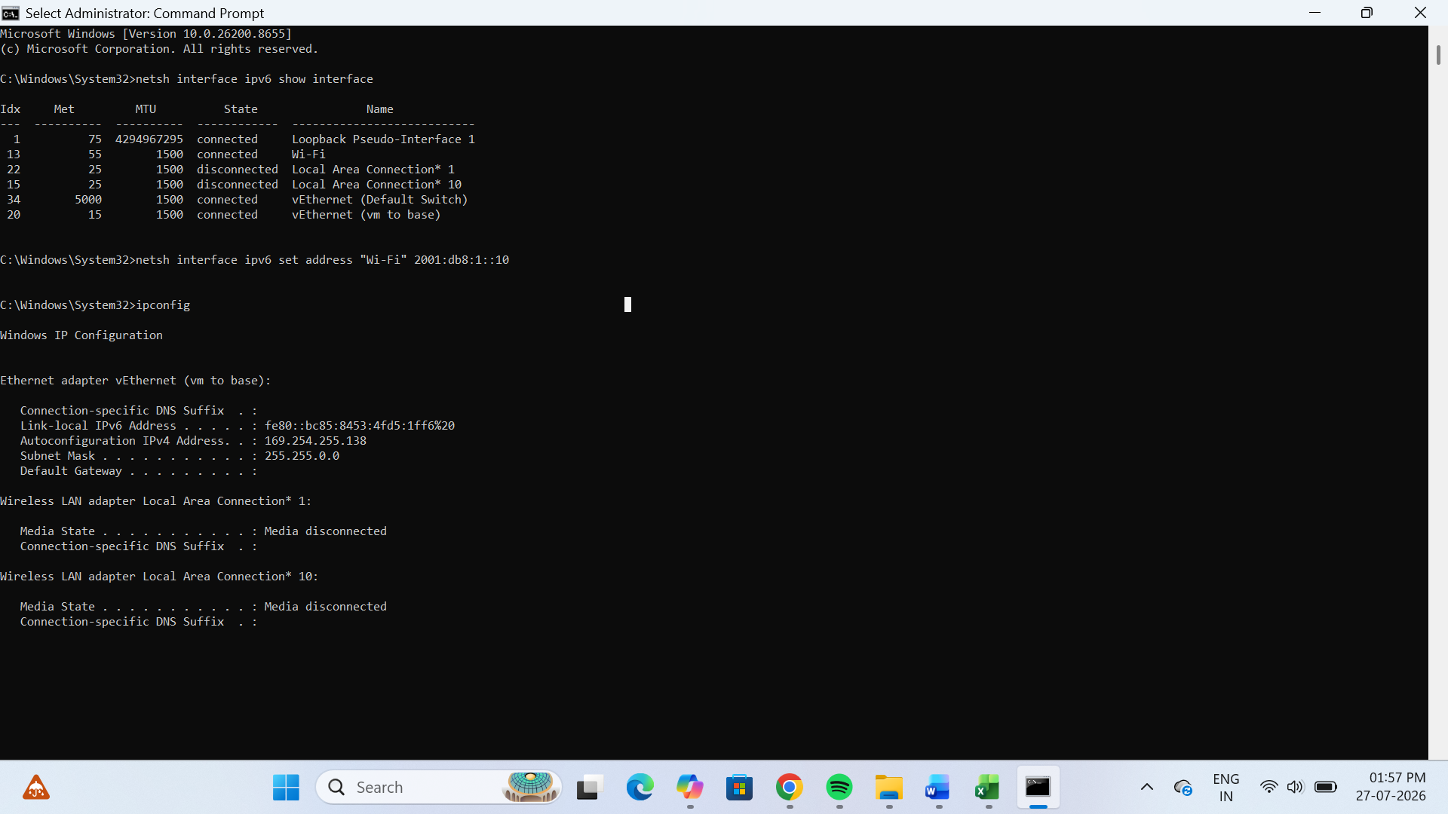
2.Configure a unique local IPv6 address (starting with 'fd') on your system and confirm connectivity by pinging another device on your LAN that also has a unique local IPv6 address.<br><br><em><strong>Hint:</strong> Use the ping6 or ping -6 command for IPv6 testing.</em>
Commands:
netsh interface ipv6 set address "Wi-Fi" fd00:1::10
ipconfig
ping -6 fd00:1::20
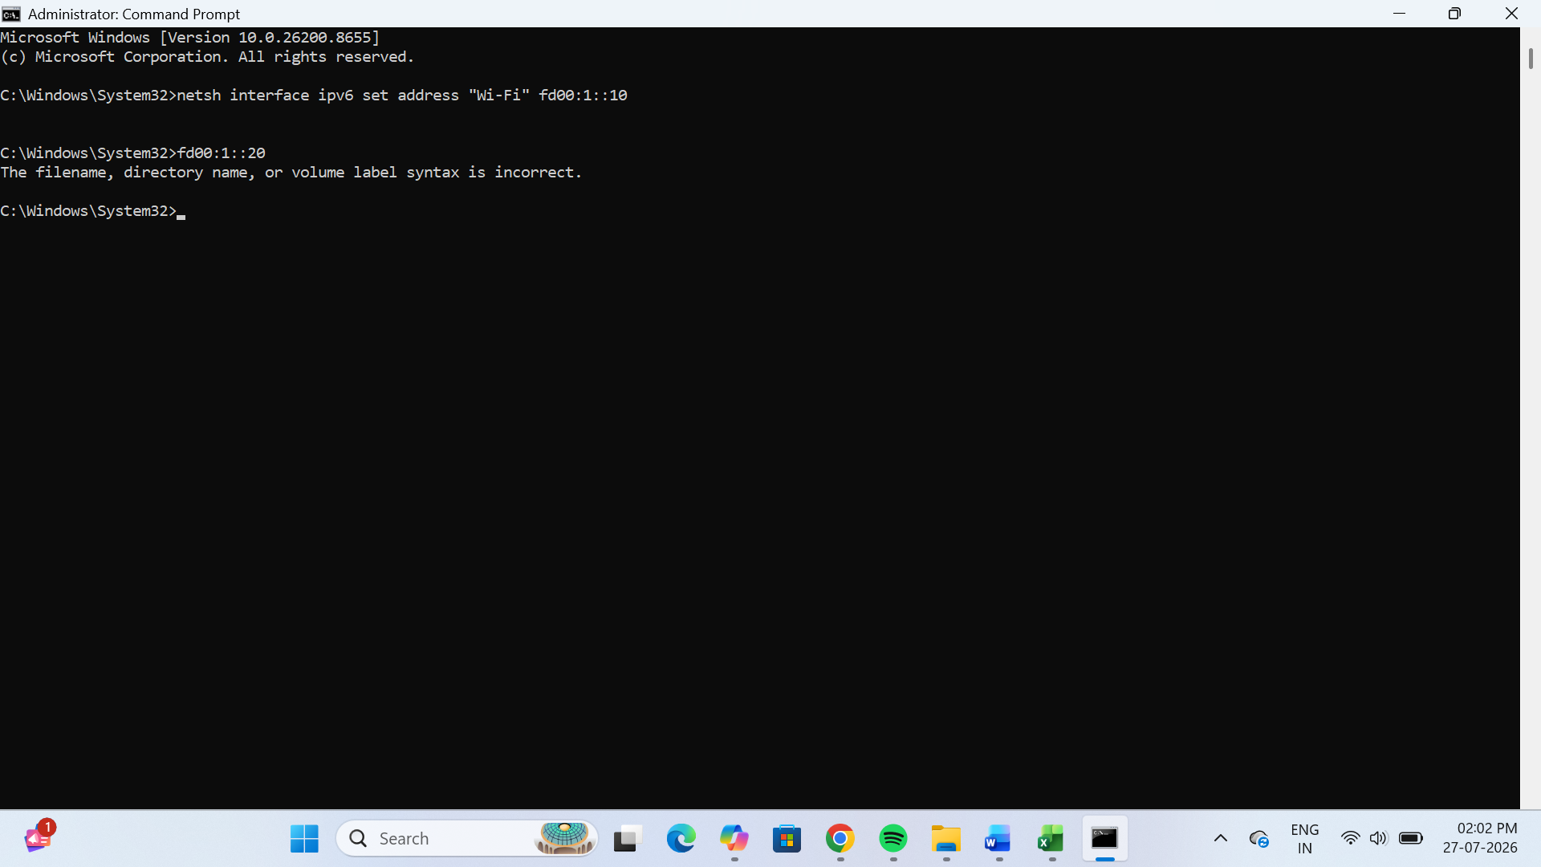
Note: Only one laptop was available, so IPv6 connectivity to another LAN device could not be tested.
3.Set up a temporary IPv6 address on your system and check if it changes after a reboot or network disconnect/reconnect.<br><br><em><strong>Constraint:</strong> Document the steps and the observed address behavior in a text file.</em>
File Name: IPv6_Temporary_Address_Observation.txt
Experiment: Temporary IPv6 Address
Steps Performed:
1. Opened Command Prompt on Windows 11.
2. Checked the current IPv6 address using the command: ipconfig
3. Verified that the system had a temporary IPv6 address.
4. Restarted the network connection (Disable/Enable Wi-Fi) and checked the IPv6 address again using: ipconfig
5. Compared the IPv6 address before and after reconnecting.
Observation:
The temporary IPv6 address changed after reconnecting to the network. This is normal because temporary IPv6 addresses are automatically generated to improve user privacy. The permanent (link-local) IPv6 address remained available, while the temporary IPv6 address was updated.
Conclusion:
The system successfully used a temporary IPv6 address. After the network reconnect, the temporary IPv6 address changed, confirming the dynamic behavior of temporary IPv6 addressing.

4.Simulate a Zomato-style search: Write a small script (any language) that stores an array of restaurant names and their IPv6 addresses, then allows the user to input a partial name and returns the matching restaurant's IPv6 address.
# Zomato Style Restaurant Search using IPv6
restaurants = {
"Pizza Hut": "2001:db8:1::101",
"Domino's": "2001:db8:1::102",
"McDonald's": "2001:db8:1::103",
"Burger King": "2001:db8:1::104",
"Subway": "2001:db8:1::105"
}
search = input("Enter restaurant name: ").lower()
found = False
for name, ipv6 in restaurants.items():
if search in name.lower():
print("Restaurant:", name)
print("IPv6 Address:", ipv6)
found = True
if not found:
print("Restaurant not found.")
5.Use ChatGPT or Copilot to generate a sample IPv6 subnetting scenario (with at least 3 subnets), and then manually assign a valid IPv6 address from one of those subnets to your system. Paste the AI-generated scenario and your configuration steps in a text file.
->Experiment: IPv6 Subnetting Scenario
AI-Generated Scenario:
A company has the IPv6 network 2001:db8:100::/48. The network is divided into three subnets for different departments.
Subnet 1: HR Department
Network: 2001:db8:100:1::/64
Subnet 2: Sales Department
Network: 2001:db8:100:2::/64
Subnet 3: IT Department
Network: 2001:db8:100:3::/64
Assigned IPv6 Address:
I assigned the following IPv6 address to my system:
2001:db8:100:1::10
Configuration Steps:
1. Opened Command Prompt as Administrator.
2. Used the following command:
netsh interface ipv6 set address "Wi-Fi" 2001:db8:100:1::10
3. Verified the IPv6 configuration using:
Ipconfig
Observation:
The IPv6 address was displayed successfully in the Wi-Fi adapter configuration.
Conclusion:
The IPv6 address was configured successfully from the selected subnet, and the configuration was verified using the ipconfig command.

